Peak Pharmacies are looking for an Intern Pharmacist to join our caring and health-focused team and assist us in serving the community across the Geelong and Bellarine Peninsula area.

About Us:

Peak Pharmacies brand is focused on service rather than price and we are very active in maximising our revenue from the 7CPA professional services such as:
- Dose Administration Aids;
- Staged Supply;
- Home Medication Reviews;
- MedsChecks; and
- Diabetes MedsChecks.

We also service a number of Aged Care Facilities across our pharmacy network, which requires managing approximately 600 patients and all their medication needs. We also supply medication services to three drug rehabilitation inpatient facilities. Peak Pharmacies also has a contract to provide clinical services to 78-bed private mental health hospital, this requires us to have a pharmacist on site for a number of hours per week.

We have Pharmacotherapy Programs at all our pharmacies, with the programs varying in size from half a dozen patients to over 60 patients. All Peak Pharmacies offer vaccination services in line with the Victorian DHHS guidelines. We focus on providing our customers with access to pharmacists to assist in patients; health needs, this is our point of focus in a Pharmacy market that is increasingly being dominated by price discounters. The role of a Pharmacist within Peak Pharmacies is a varied and interesting role. Each Pharmacy is run by a Managing Partner Pharmacist who all have a great depth of experience and work within the Pharmacies on a full time basis. For more information about us please visit www.peakpharmacies.com.au.

About the Role

As Peak Pharmacies continues to grow and we are looking to employ an Intern Pharmacist who can develop with the business and support our Pharmacists as the workload continues to increase. The position would be working closely with the Pharmacist and learning the roles and responsibilities that are required to perform this job in a dynamic Pharmacy environment. There is the potential to continue with Peak Pharmacies at the completion on the internship. Peak Pharmacies are committed to the growth and development of our team and upholding a positive work environment in which our team members feel supported.

We will provide the Intern Pharmacist with a specific training program that is based on the Community Pharmacy Intern Training Plan provided by AHPRA. The opportunity would is to be placed at one of our five Pharmacies, we would carefully consider and match the applicants interests and needs to one of our Pharmacies. The candidate would also be given the opportunity throughout their internship to work across our network of Pharmacies to gain varied experiences to have strong development as a future Pharmacist.

About You

As a successful applicant, you will be a self-starter, be capable of delivering exceptional customer service in a professional manner and have the desire to be a part of a motivated team. You are eager to learn, accept guidance and feedback well. You will be strong with time management and have a positive, can-do approach to work.

It is essential that you possess the ability to work in a team as a hands-on, practical individual who enjoys working in a fast-paced, dynamic environment. Being a key member of the team, you will display excellent communication skills with consultation and problem-solving abilities. Please see below for an outline of the major aspects of the role description.

Responsibilities
- Dispense medicines under the supervision of a registered pharmacist
- Provide medicine counselling to customers under the supervision of a registered pharmacist
- Support the provision of professional services available in the Pharmacy as required
- Collaborate with other health professionals to support patient care when required. This includes but is not limited to, discussing medicine availability, clarifying prescription detail, referral of customers and liaising with hospital pharmacies
- Supply Pharmacist Only Medicines under the supervision of a registered pharmacist
- Assist in stock management, including maintenance of dispensary stock including stock rotation, ordering and expiry-date checking
- Liaise with pharmaceutical representatives regarding product ranges and drug information
- Assist the pharmacy to comply with Commonwealth and State legislation which relates to the operation and practice of pharmacy
- Comply with all policies and procedures in place in the pharmacy
- Comply with all professional guidelines and codes which apply to the practice of pharmacy
- Undertake other duties as required
Staffing and staff performance
- Provide customers with high level of customer service to go beyond their expectations and build loyalty and customer return
- Behave in a manner which reflects honesty, loyalty and integrity and presents a positive image of the Peak Pharmacies brand at all times
- Apply work practices as required under State and Federal Work Health and Safety Legislation and associated Codes of Practice and ensure compliance with Equal Opportunity and Discrimination legislation
- Attend meetings with staff, management and preceptor as required
- Be aware of in-store promotions and generate interest amongst customers
- Comply with the Pharmacist Code of Ethics while practising supervised
- Be active and committed in learning & development of pharmacist knowledge both when working in the pharmacy and during sessions with the preceptor pharmacist to fulfil the requirements of the Intern Training Program

Sponsorship Opportunity

We are passionate about the health of Australians and the work of Pharmacists in Australia, which is why we are excited to support the successful candidate for our Intern Pharmacist position to complete the Intern Training Program within our Pharmacies, we will also gladly support the candidate through the Intern Foundations Program (if applicable).

Peak Pharmacies is happy to include sponsorship to the value of Domestic fees for the Intern Training Program for the successful Intern Pharmacist candidate. If you are at a University that offers a research project as part of a Masters program we may also include the value of the Domestic fees within the sponsorship amount.

If this position description sounds like you, we would love to hear from you.

For a confidential discussion about the position please email Bonnie at bonnie.plumridge@peakpharmacies.com.

Along with a resume, all applications must include a cover letter introducing themselves as a current student & future pharmacist, what your passions in Pharmacy are, what they most hope to gain from completing your Intern year and also addressing why they believe they would be the best candidate for the Peak Pharmacies Intern Pharmacist position.

If you want to get a feel for what an Intern year looks like with Peak Pharmacies please read on for an interview with our 2021 Intern Pharmacist – Akira!

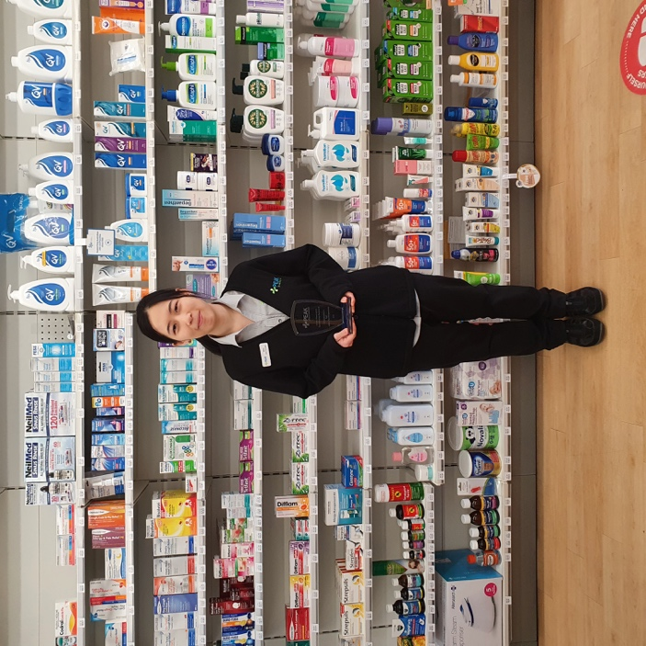
Interview with Akira – Intern Pharmacist with Peak Pharmacies for 2021
Akira is currently completing her Intern Training Program and Intern Foundations Program through Monash at Peak Pharmacies. Akira has been working as an Intern Pharmacist with the Peak Pharmacy Leopold team since January 2021. We are excited to be partnering with Akira on her journey through her final year of study before becoming a Registered Pharmacist. Along with Akira’s successful candidacy for the Intern position, it was with great pleasure that Peak Pharmacies sponsors Akira for the Fees of her final year at Monash University. You can find out more about Akira’s Intern year so far in the Q&A below:

Q: Can you please tell me a bit about your experience as an Intern Pharmacist with Peak Pharmacies so far?
Akira: As an intern at Peak Pharmacies I am able to be a part of providing care for patients in the variety of ways that Peak Pharmacies offers. Peak Pharmacies runs many pharmacy services to improve patient’s health, including MedsChecks, blood pressure monitoring, an opioid substitution program and medication supply and management for nursing home patients. These practical exposures enhance my internship experience, and although there is always much to learn, my preceptor, pharmacist supervisors and team members are all very supportive. They have helped me to develop my clinical knowledge and skills and have taught me many things throughout the year.
Q: What's the most enjoyable part of your week working in the Pharmacy?
Akira: The most enjoyable part of my week is having the opportunity to build a good connection with patients through the services offered at Peak Pharmacies. There are lots of opportunities to get to know patients while providing care, and I believe that good communication is vital to make a positive impact on a person’s health.
Q: What was it like to be awarded with Peak Pharmacies Intern Pharmacist Sponsorship Award?
Akira: I am very honoured to receive the Intern Pharmacist Sponsorship award. I am already so thankful for the continued support throughout my internship, and this award makes me want to try even harder for Peak Pharmacies.

Q: In your Pharmacy, you are rostered to work with your Preceptor as well as 3 other experienced Pharmacists during the week, two of which are owners. What has working alongside different Pharmacists each week given you?
Akira: I am glad that I am able to learn from different pharmacists during the week. I learn a lot from every pharmacist I work with, and although everyone has differences in communication styles and ways of thinking through problems, everyone still shares the same core values of providing patient-centred, good-quality care. It helps me to gradually develop my own way of communicating with patients in the best way that I can.
Q: How have you found the Intern Training Program that you've been working through?
Akira: I am currently undertaking the Intern Training Program (ITP) at Monash, which complements well with the practical things that are learnt on the job. The ITP learning tasks and tutorials with my preceptor keep me on track with medication and condition knowledge that we are required to study throughout the year. Additionally, my preceptor and supervising pharmacists are an invaluable point of contact to clarify or discuss details about pharmacy practice and medication knowledge that I have learned about.
Q: Which has been your favourite Preceptor tutorial and why?
Akira: I have tutorials with my preceptor every week, focusing on a healthcare topic and legal aspects of pharmacy practice. These tutorials help me to retain knowledge that I have studied, and helps me to put things into perspective of how I can apply what I have learned to the workplace. My favourite preceptor tutorial is when we went through the over the counter cough, cold and flu products. My preceptor brought in the products that are available in the store into the tutorial room, and we discussed when we would recommend each product and their counselling points. As there are usually a wide range of cough, cold and flu products available in pharmacies, I found it an important session to become familiar with the products that are available in our particular store, which will help me when engaging in conversation with customers about these products.
Q: Is there anything you're really looking forward to as you continue to work through the remainder of your Intern year with Peak Pharmacies?
Akira: I am particularly looking forward to working on my research project this year. It will be my first individual project and I am excited to be able to start it from scratch. I have discussed its premise with my Preceptor Chris, HR Manager Bonnie and Managing Pharmacist Andrew, and I hope that the findings from this project will contribute positively to the operations at Peak Pharmacies.

